What was covered:

**J.A.W.S. Procurement Ltd.**

***\*\*\*!!DEADLINES ARE MENTIONED AT THE END!!\*\*\****

*-Discussing task division for sprint 2*

***Things to do:***

* ***Code the user interface (front end)*** → Valeria, Laura, Abdullah
  + From user stories (features):
    - Login page(supervisor, employee or supplier) + create account/sign-up (full name of employee, their email, password, confirm password)
    - List items for selection (image, price/qty, item id, description?)
    - (Cart) Confirmation page of items selected + if the total amount is over 5000$ it’s pending (button to send to supervisor)
    - Quotation page (employee: sent quote, supervisor: quote)
    - Receipt
* ***Code the back end***→ Hassan, Tommy, Abdullah
  + Database (items, suppliers…)
  + Modify current code
  + To see (either convert to php or JS or new code)
  + Compare suppliers and give quote
  + Send quote to supervisor
* ***Installation Guide*** → Mounir, Hassan
  + Intro
  + Pre-installment requirements
  + Installation
  + Configurations
  + Troubleshooting
* ***User Guide*** → Mounir, Hassan
  + Introduction + purpose
  + System overview
* ***Test Document*** → Mariam, Hassan, Valeria
* ***Product Backlog*** → Laura, Tommy, Mariam, Valeria
  + Features that we have implemented + will implement in future sprints →
    - User stories
    - Assign story points
    - Features table (function, description, input, output…)
    - Assign time worth
    - Diagrams:
      * Use case Diagram
      * Class Diagram
      * Sequence Diagram
      * Logic Diagram
* ***Sprint Backlog*** → Laura, Mariam, Tommy, Valeria
  + Features that we have implemented + will implement in future sprints →
    - User stories
    - Assign story points
    - Features table (function, description, input, output…)
    - Assign time worth
    - Diagrams:
      * Use case diagram
      * Class Diagram
      * Sequence Diagram
      * Logic Diagram
* **Teamwork Discussion Sheet**

***Deadlines:***

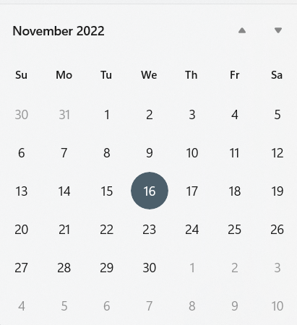

*1st deadline (Front-end, backlog user stories) :* 19-20th November

*2nd deadline (Back-end, features, diagram):* 26-27th November

*3rd deadline (Documentation)*: 29-30th November

***Project deadline: December 1st***